1. Once again vue cli:

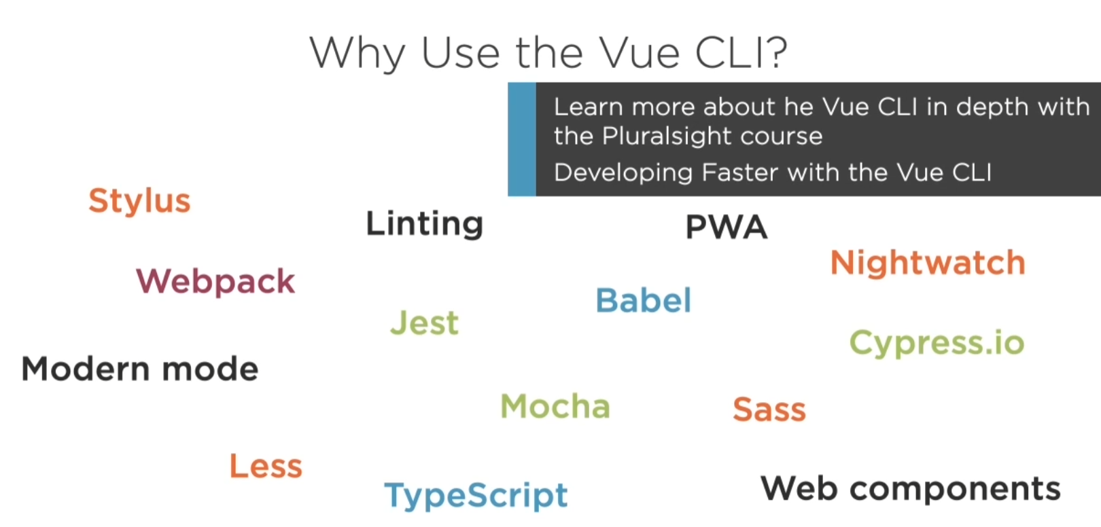

1. Useful extension:

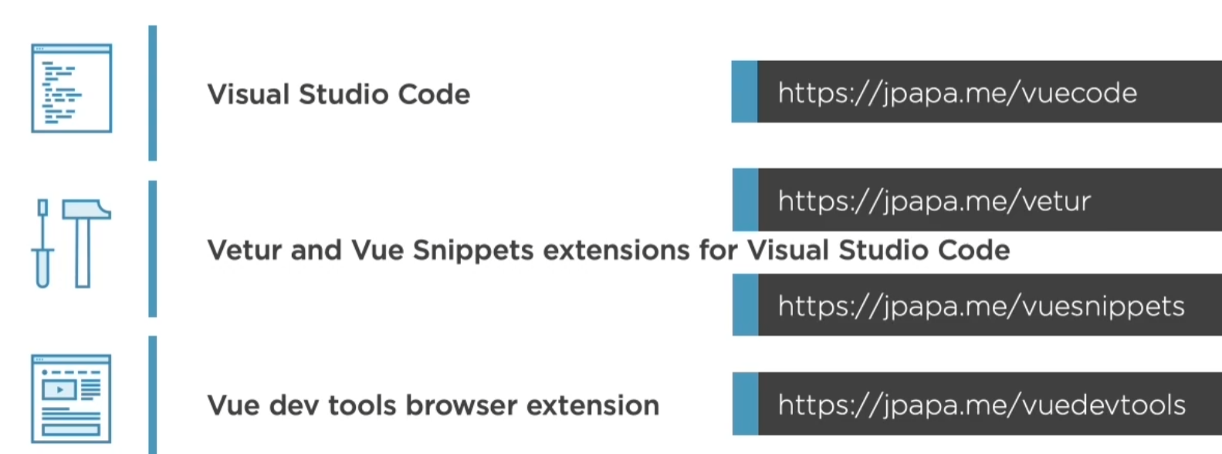

1. Get start:

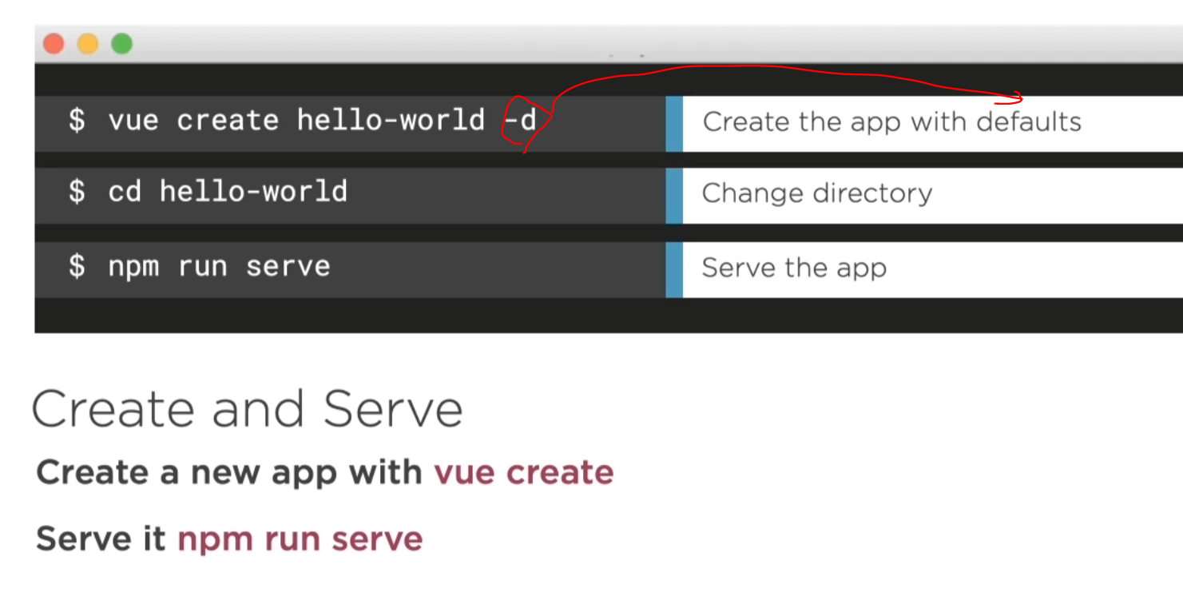

* Basic component: (with template script and style)

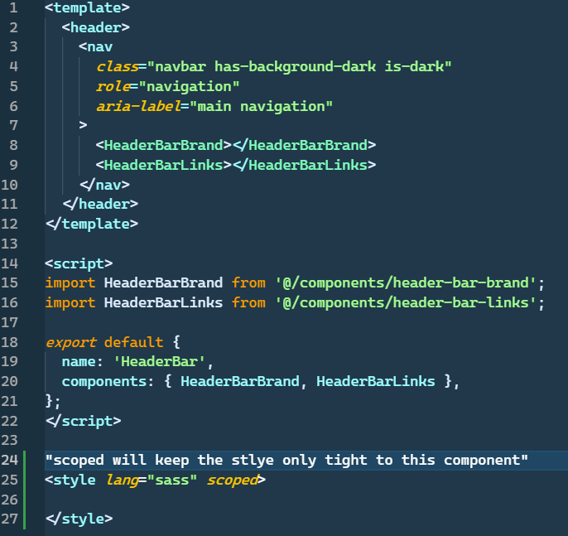

* Data biding #1

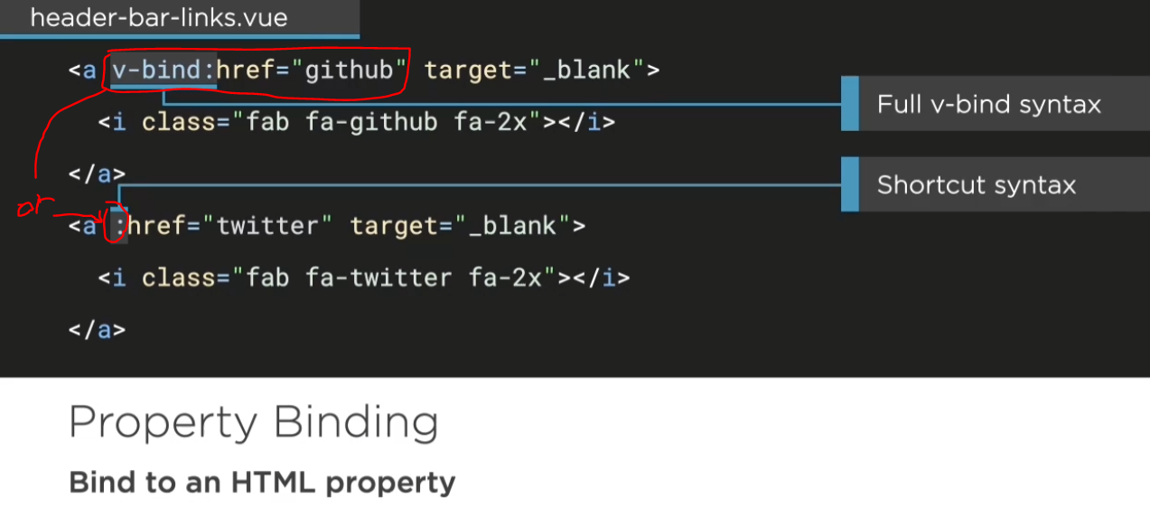

**跟 ng-class , ng-style , ng-href 等等很像**

**只要是html tag，都能加 : ，後面再bind你處理好的資料!**

**>> :class=”” / :style=”” / :img=”” / :href=””**

* **Npm install (or npm i) >> 跟C#的nuget一樣，每開一個新的proj都需要重新裝載**

**First try: bind href:**

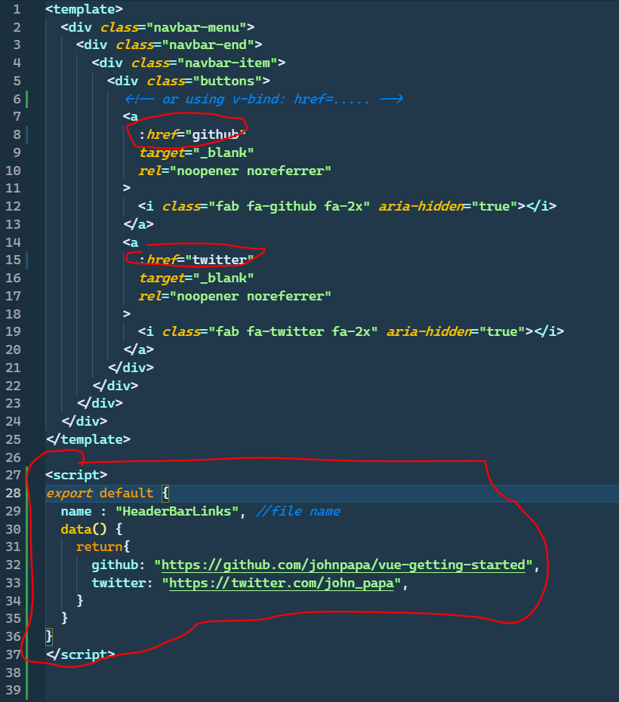

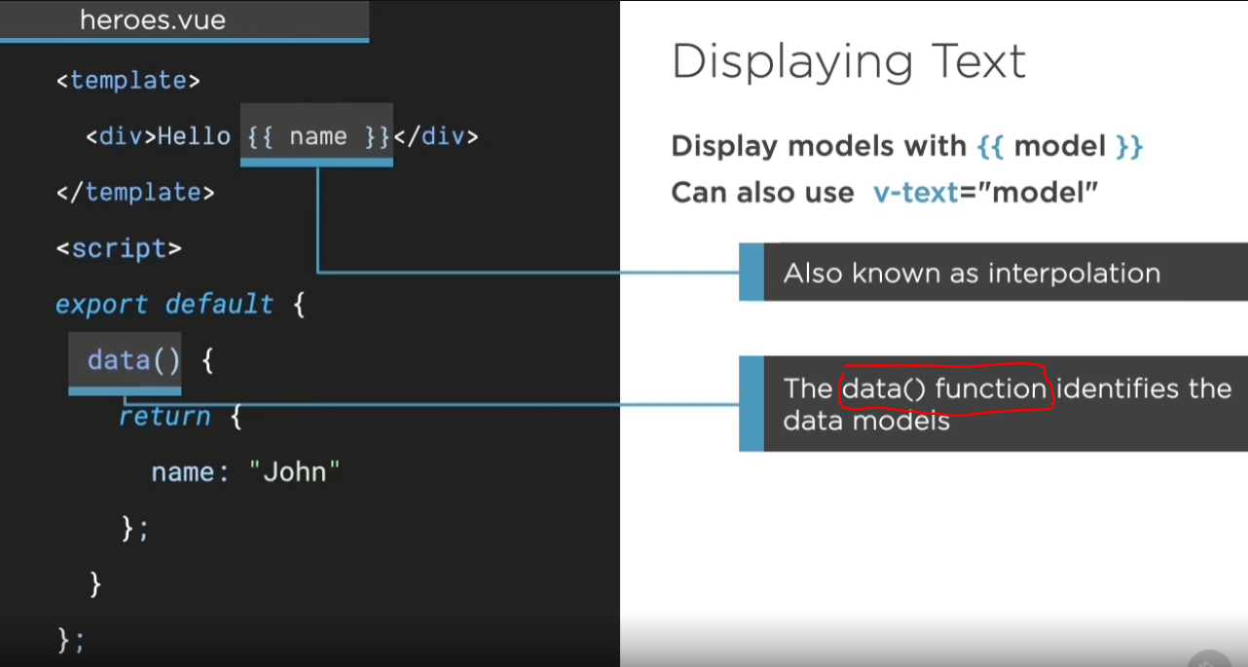

**Models binding go through the data function and return the data models**

**重點:**

**在data function 中宣告好要bind的model之後，在template中一樣用{{}}把資料秀出來**

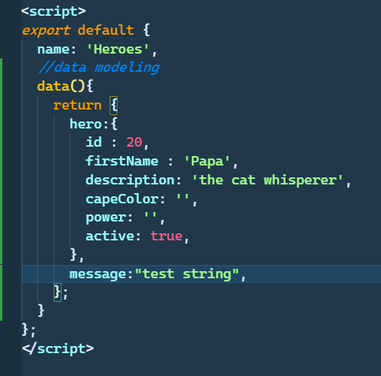

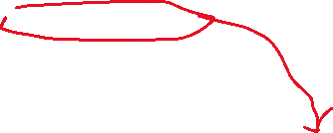



**Handling events >> v-on:event=’method-name’**

**Ex: v-on:click=”method” ,or use shortcut >> @click=”method”**

**中間要放() 或不放皆可，如果沒有params**

**@click=”method()” or @click=”method”**

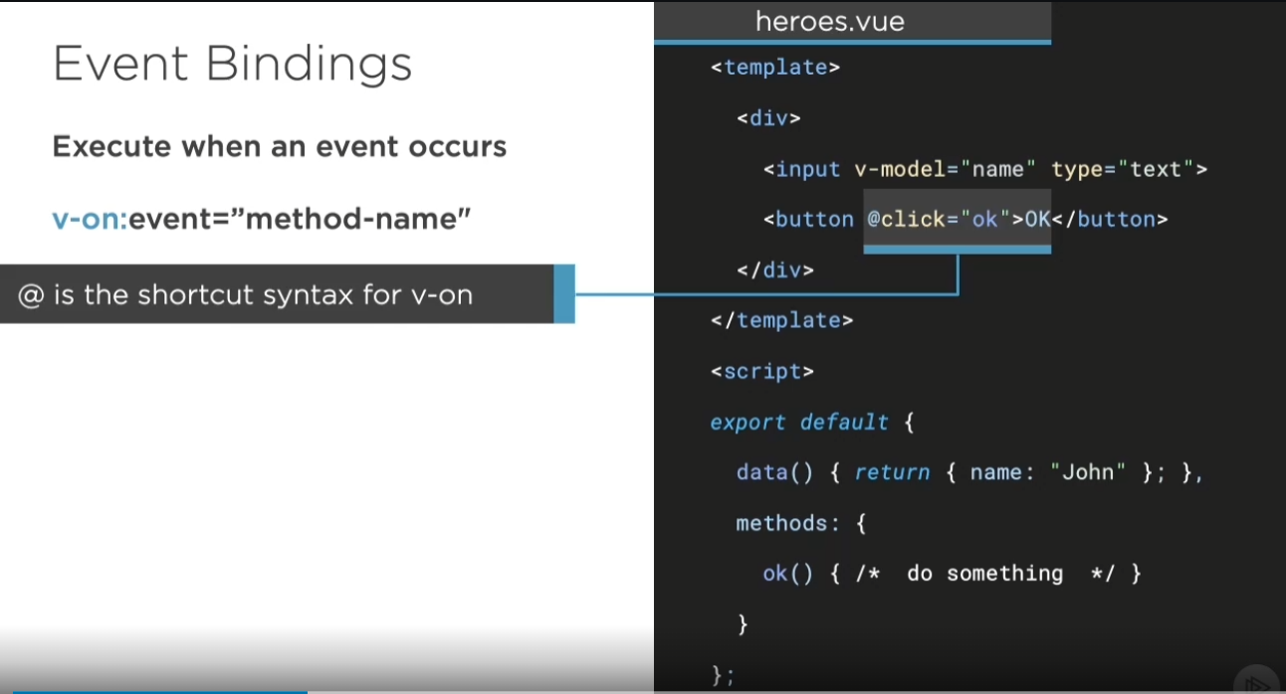

**第二步，在data function同一階層生成methods property(可用vmethod關鍵字加tab快速生成)**

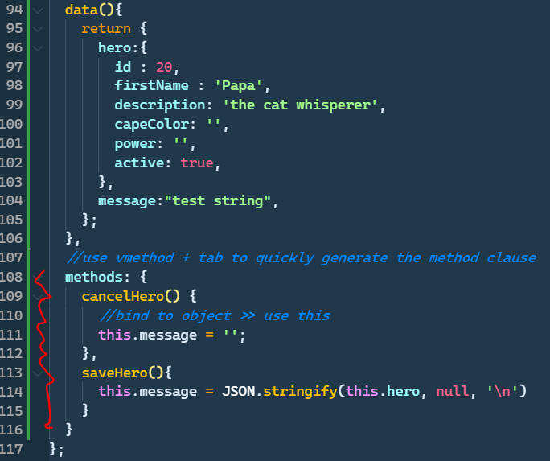

* **Two-way binding >> use v-model=”property name”**

**\*\* npm serve 存檔自動跑，連refresh都不用**

* **用v-bind:style=””( or :style=””) 來設定互動式style!**

**(在bind裡面直接寫css expression)**

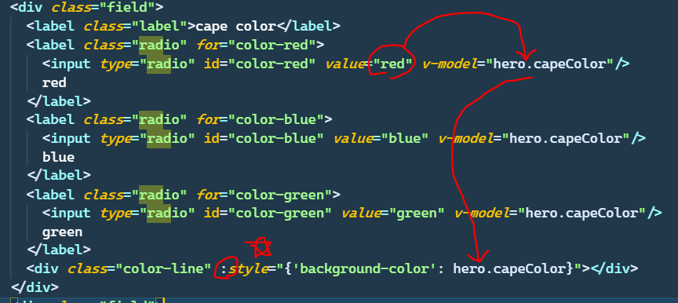

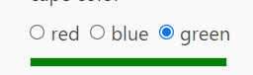

**Key modifier and class binding**

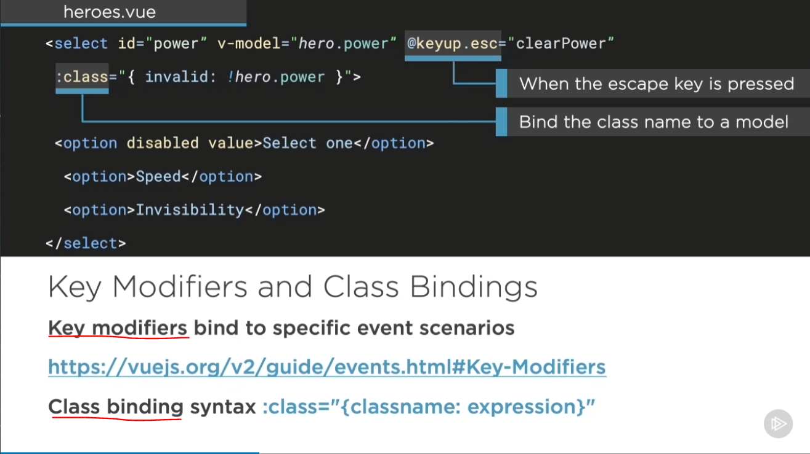

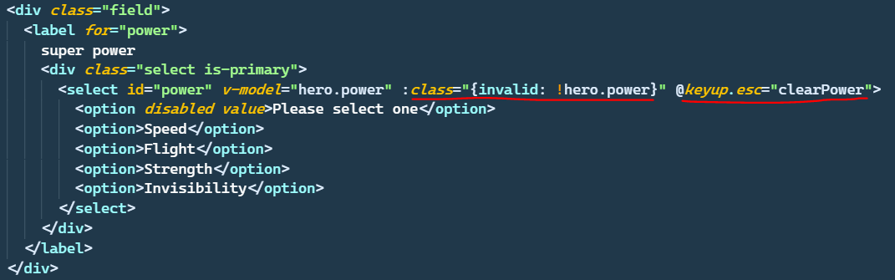

1. **讓invalid class只在hero.power 是empty時出現(條件判斷)**

**>> :class=”” 裡面開{}可以做條件判斷!**

**2.按下esc(escape)時會觸發clearPower function (把power 清掉)**

**>> 還有其他很多按鍵可以用**

**Recap:**

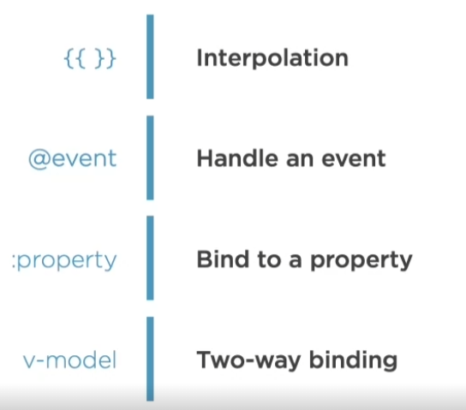

**Session 2: List and Conditionals**

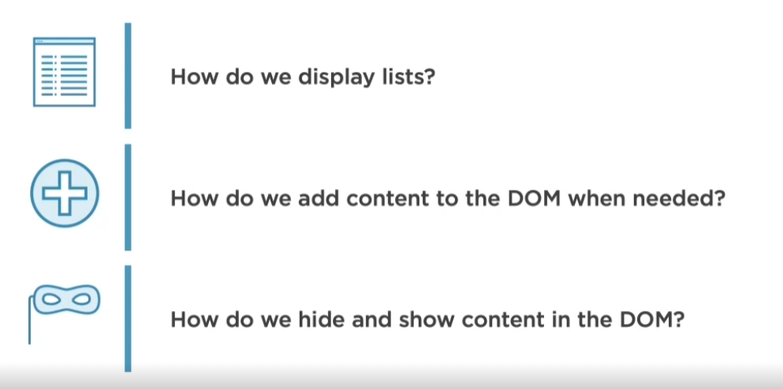

**Render a List >> v-for=”item in item-list”**

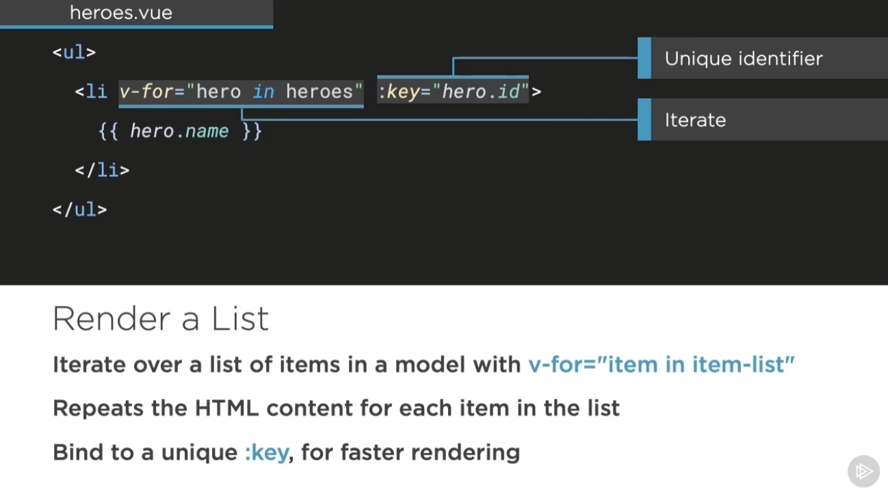

**Unique identifier: better way for vue to identify each row uniquely >> 為後續變化**

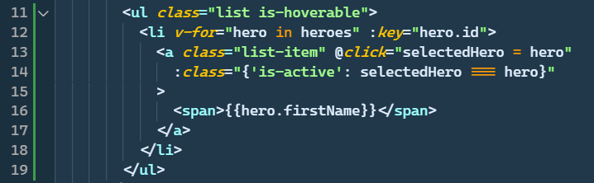



1. **Just like ng-repeat**
2. **Click function will set selected object to the specific hero**
3. **Conditional class expression**

**\*\*\*** 

Handle property undefined problem if set the selectedHero object to undefined

>> it’s recommended to set object to undefined if default is nothing (no one selected)

>>but has to deal with this problem

Use v-if 來避免undefined問題

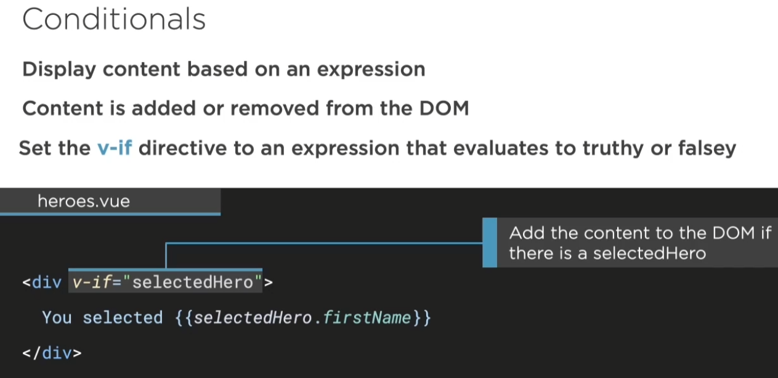

**This div is never executed, not just no show!!**

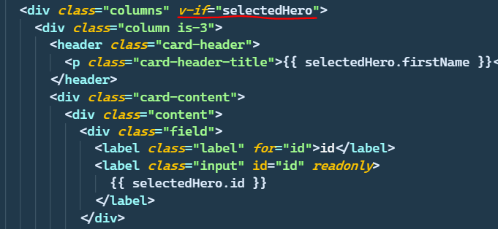

**>> 結論: 不要讓DOM去碰到undefined的東西，如果undefined就v-if屏蔽掉它**

**Another thing v-show**

**>> still exist but not show (set style to display:none)**

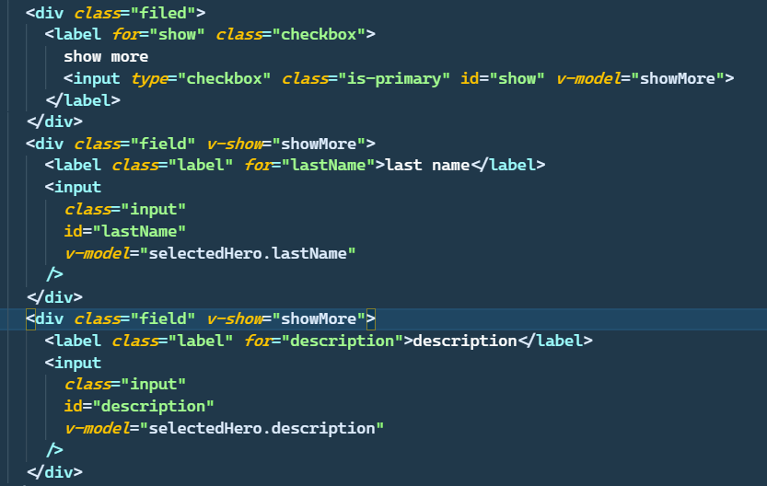

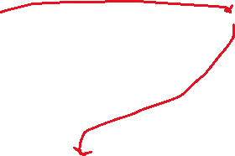

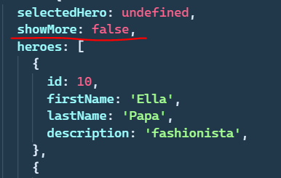



**Recap:**

